If Iris is configured for Login, then the following screen will display

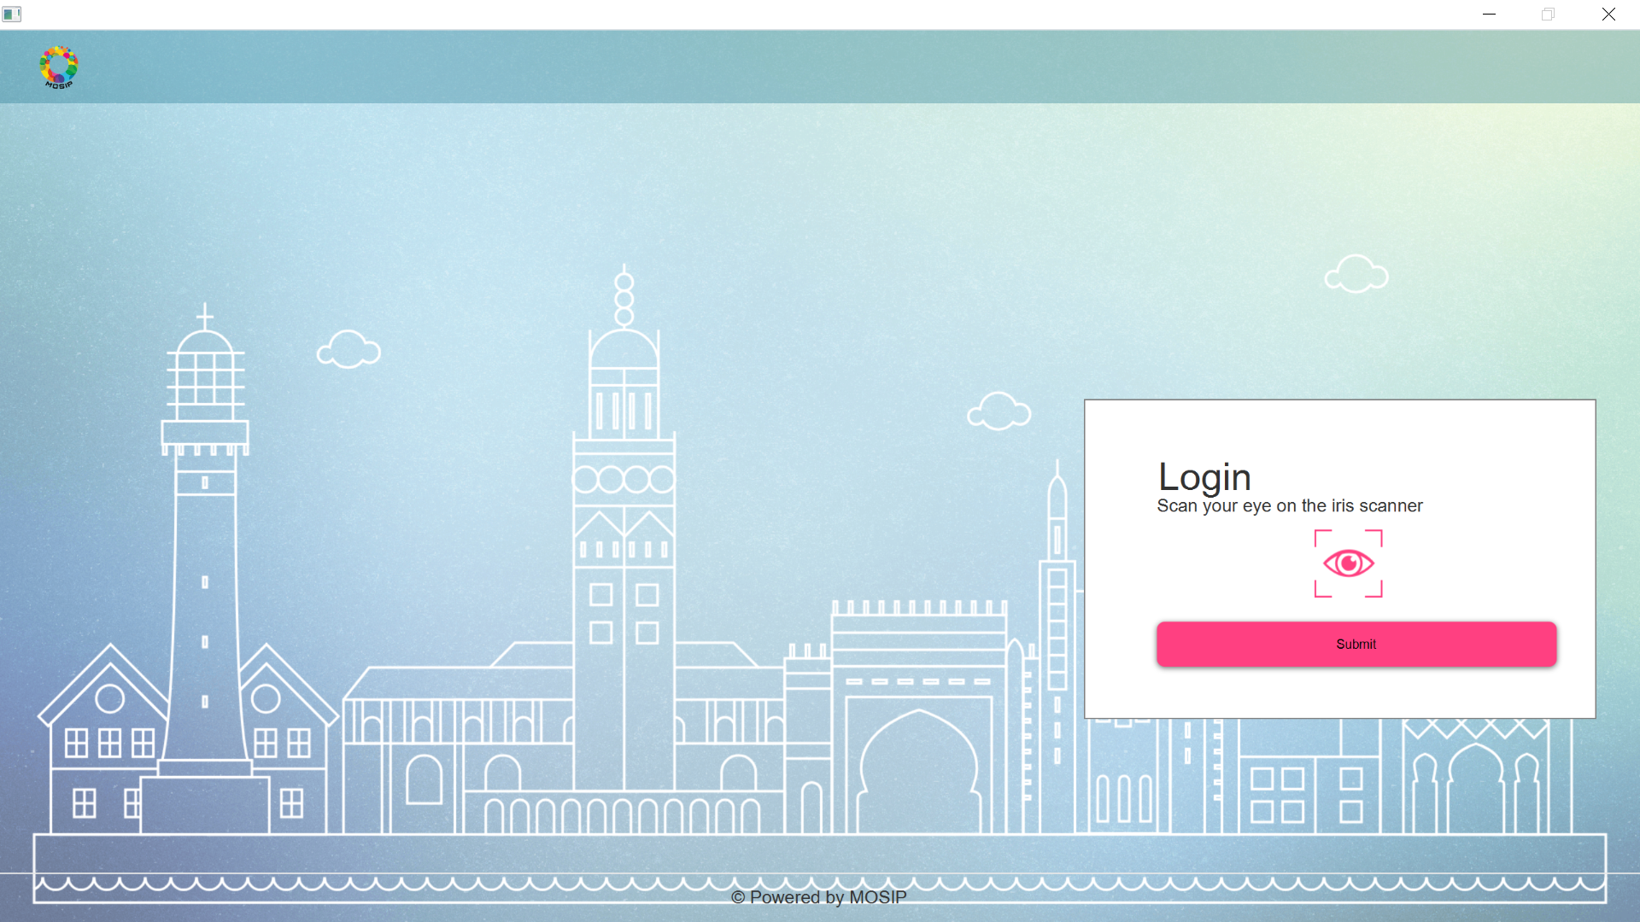

If Iris is not configured and Iris is the only mode of Login, then the following message will be displayed.

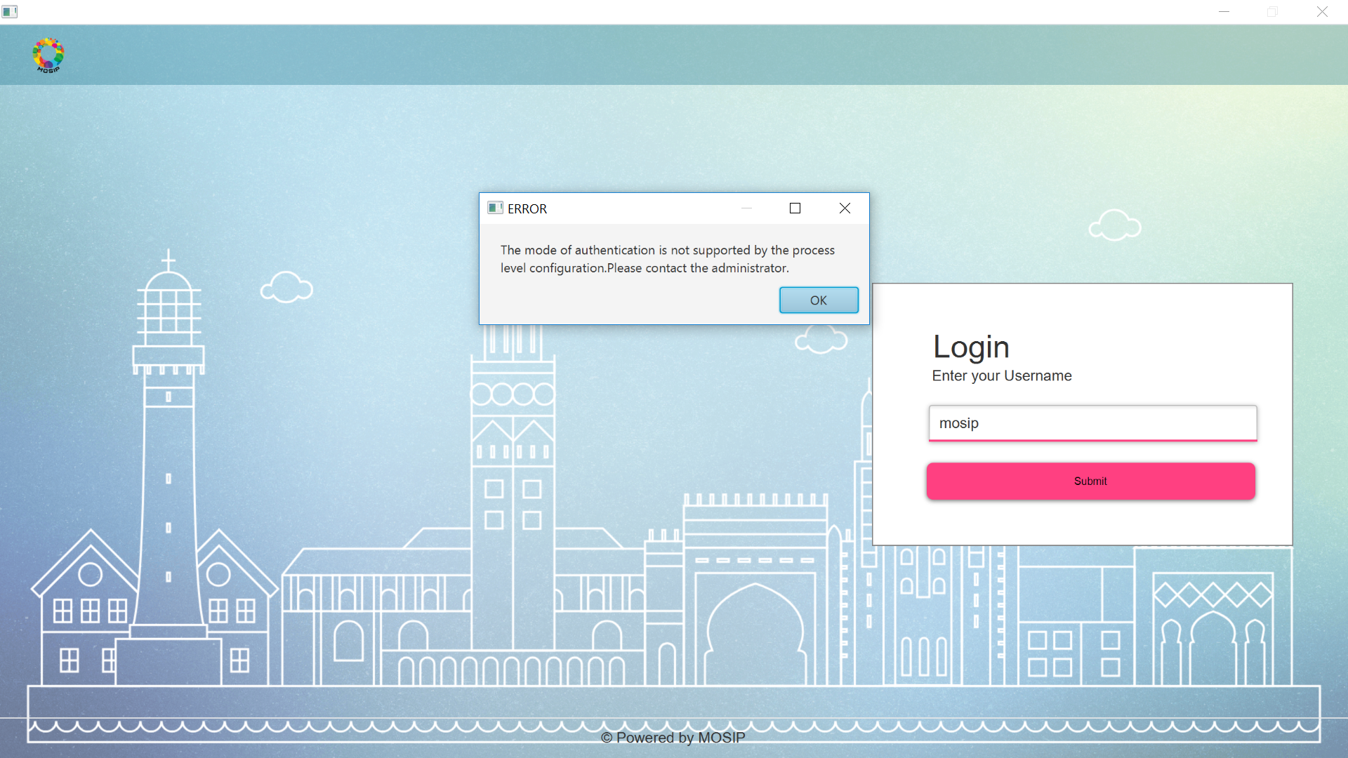

If Iris configuration is enabled, then the biometric exception will look as follows

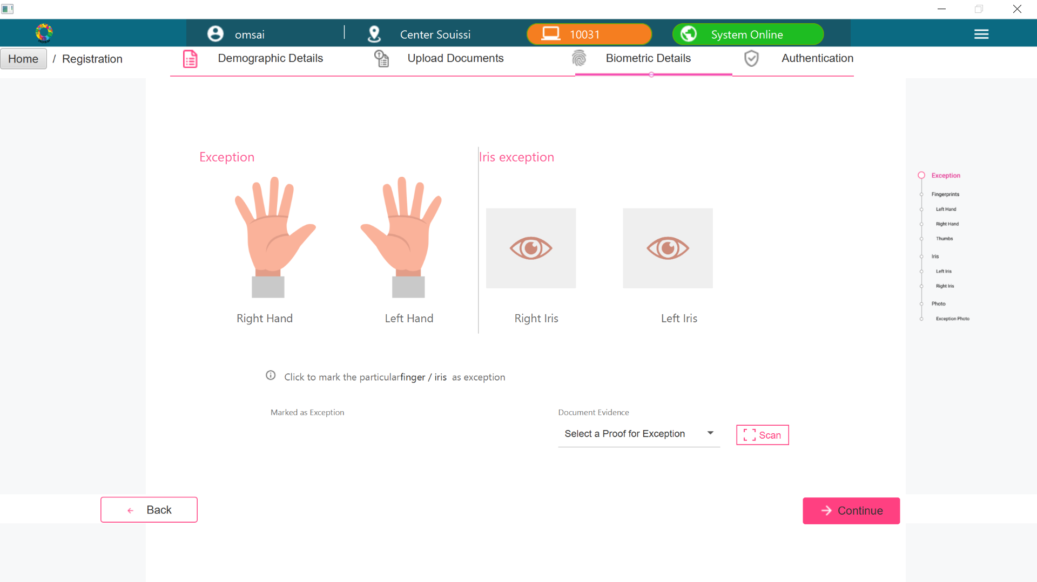

If Iris configuration is disabled, then the biometric exception will look as follows

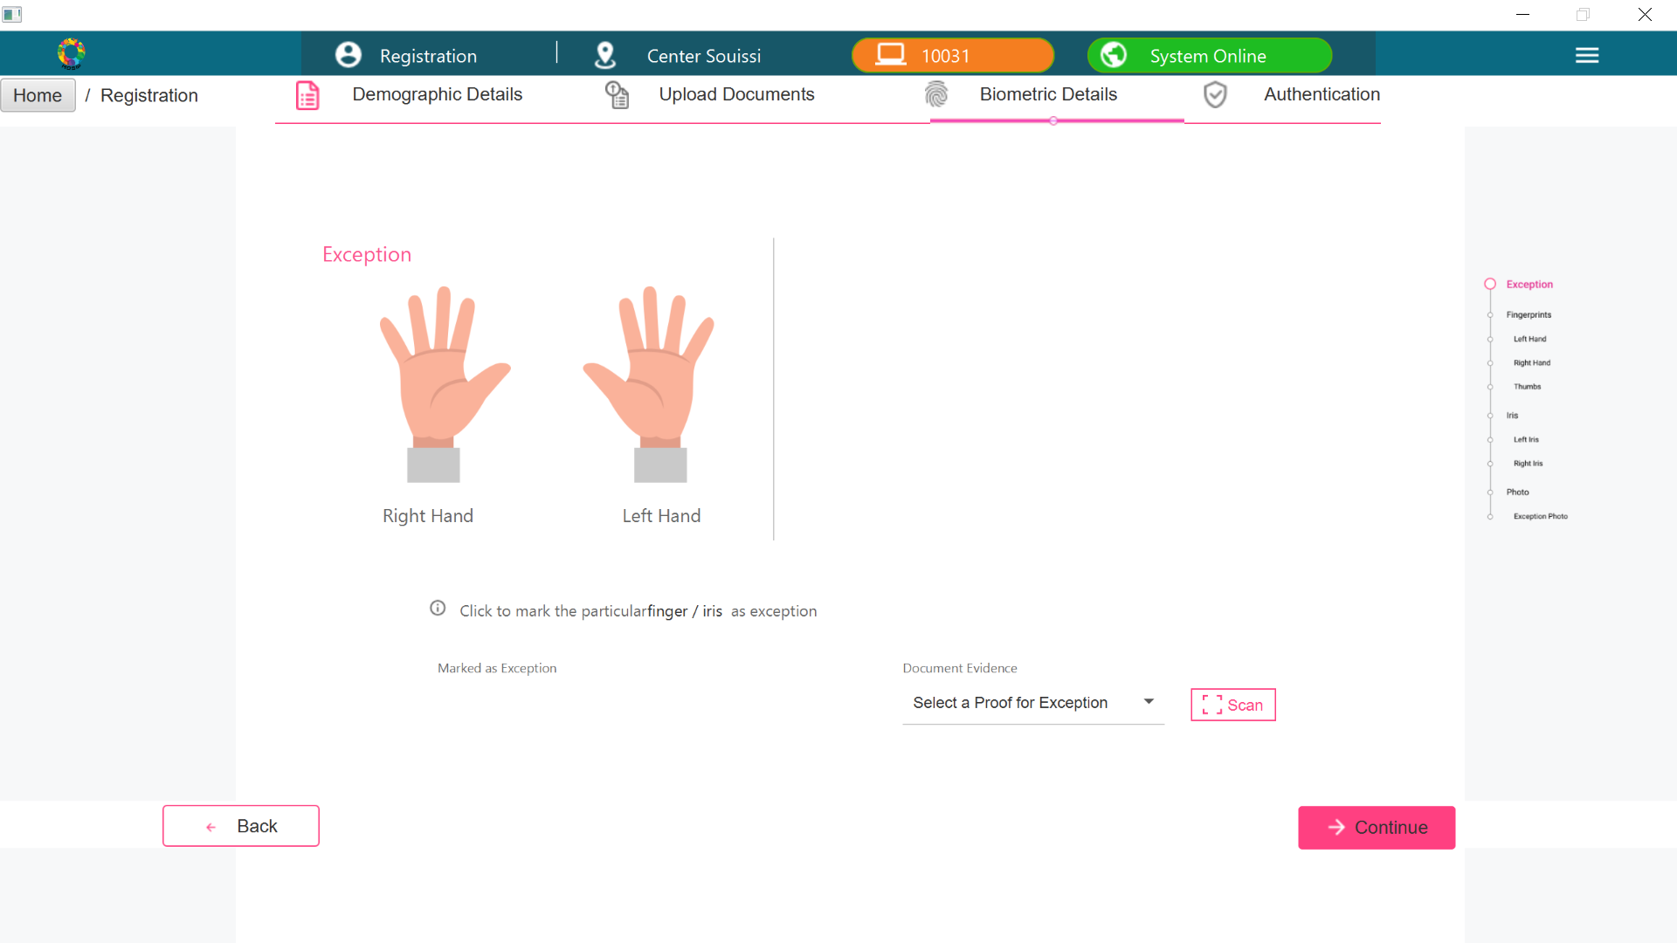

If Iris configuration is enabled, then the Iris capture will look as follows

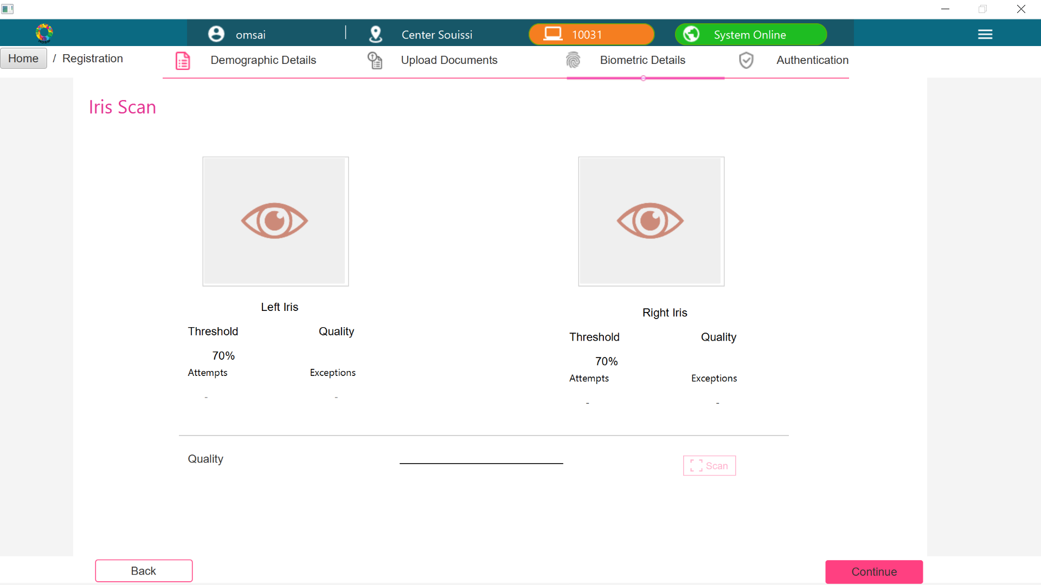

If Iris configuration is disabled, then above screen will get skipped

If Iris configuration is enabled, then the preview screen will look as follows

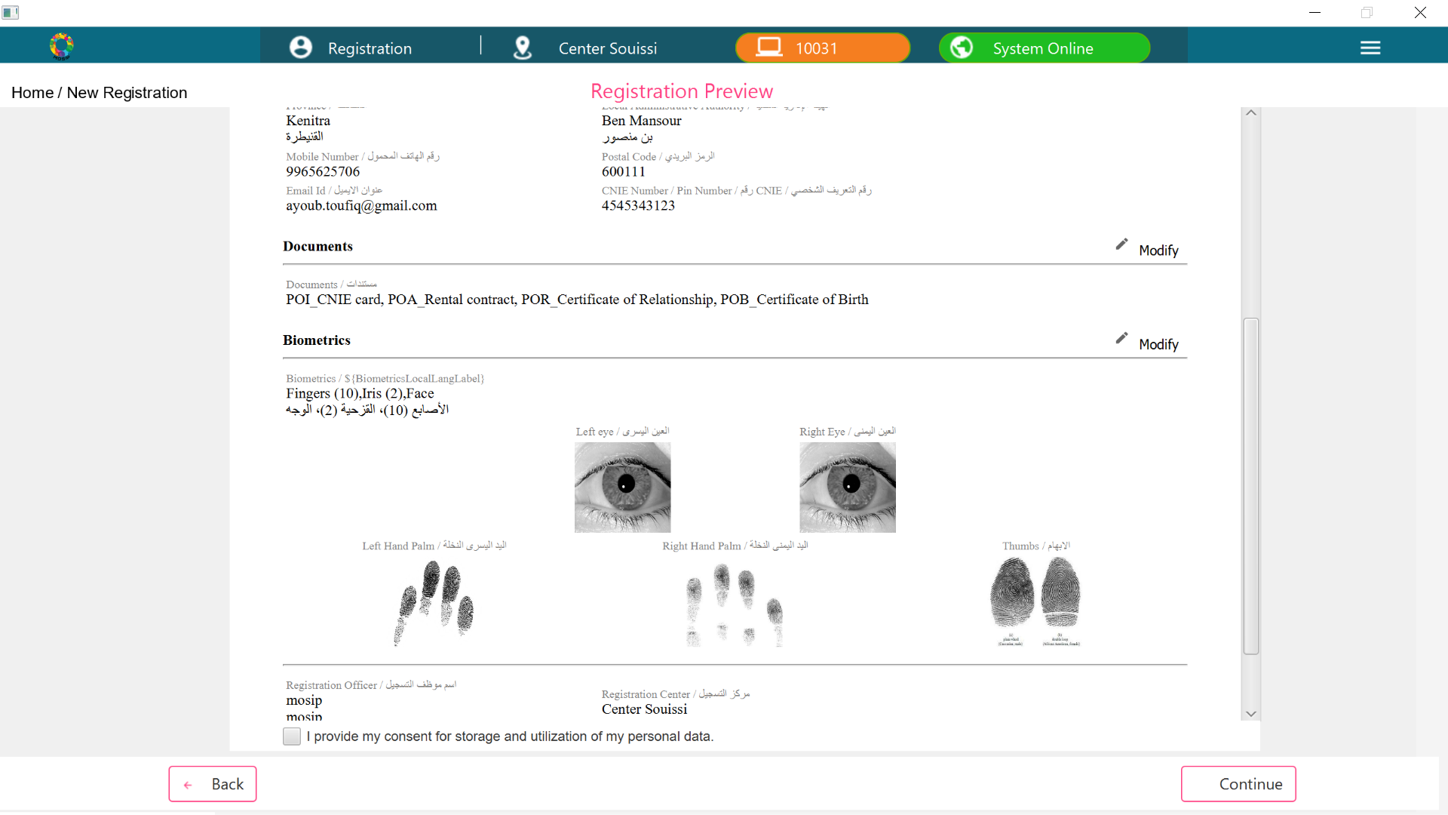

If Iris configuration is disabled, then the preview screen will look as follows

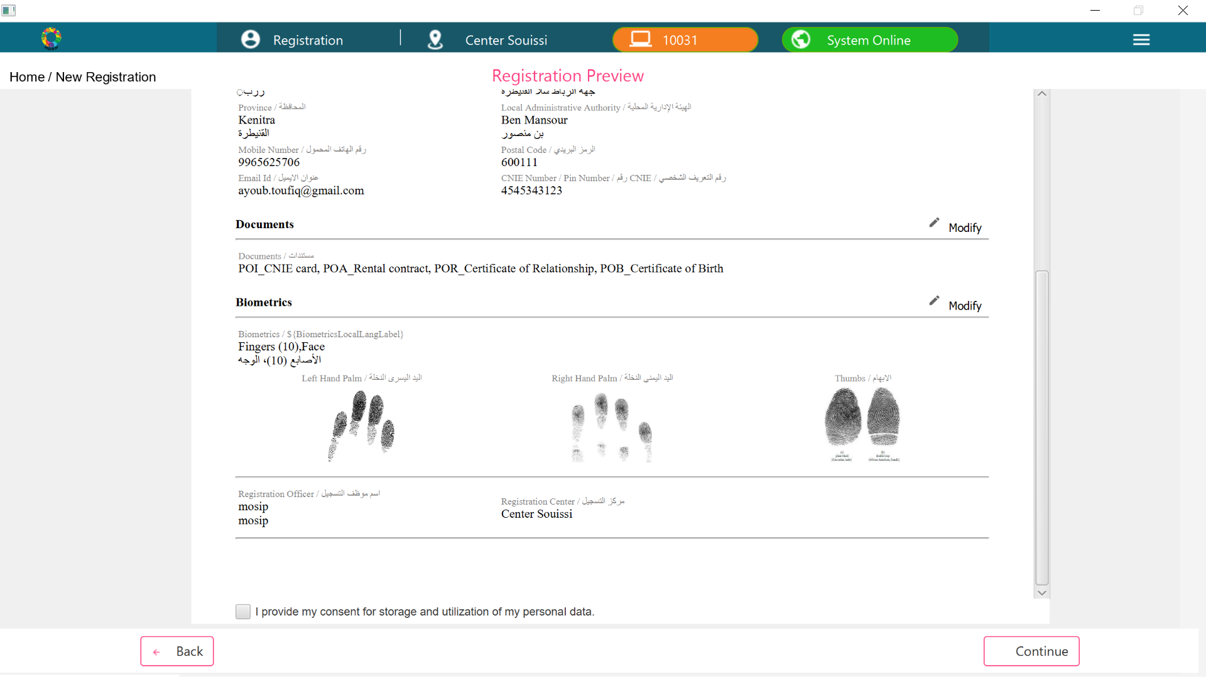

If Iris configuration is enabled, then the Operator Authentication screen will look as follows

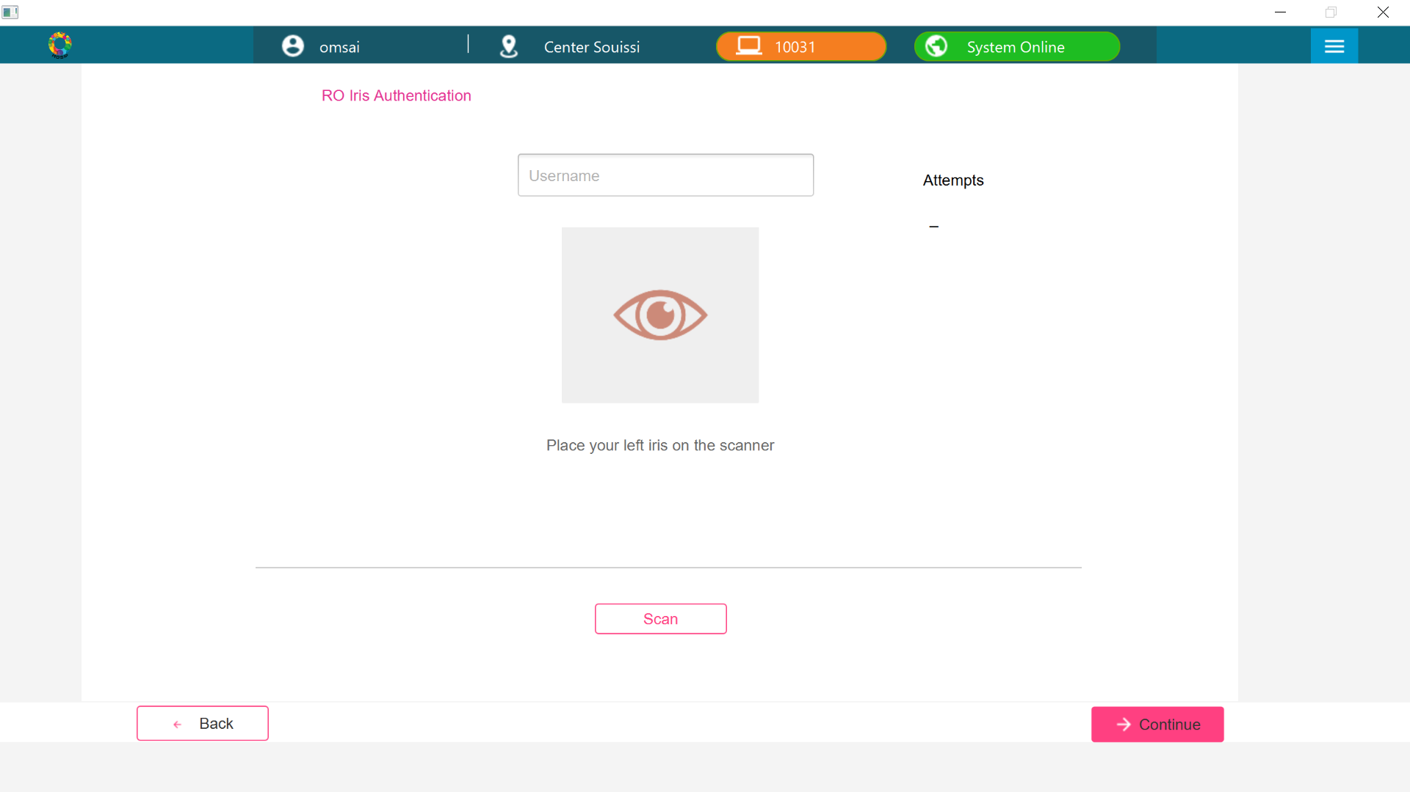

If Iris configuration is disabled, then the Operator Authentication screen will look as follows

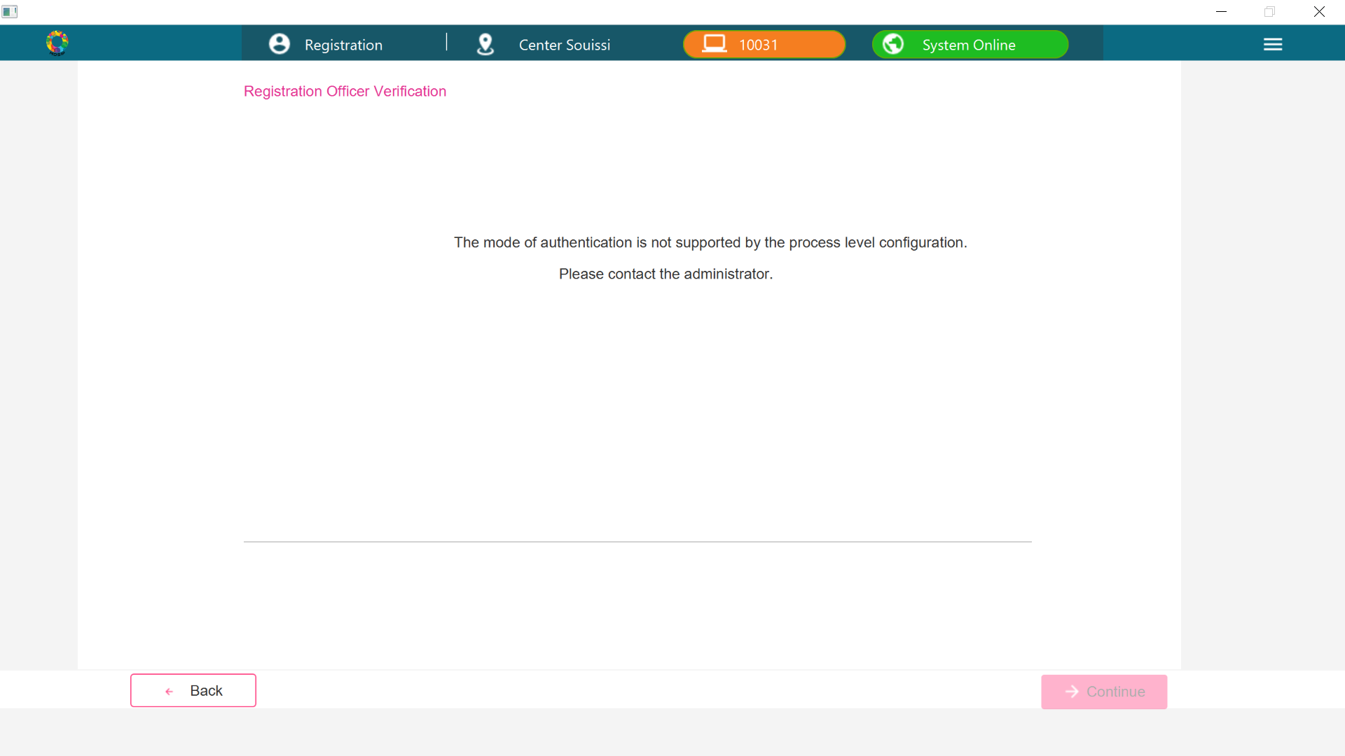

If Iris configuration is enabled, then the Supervisor Authentication screen will look as follows

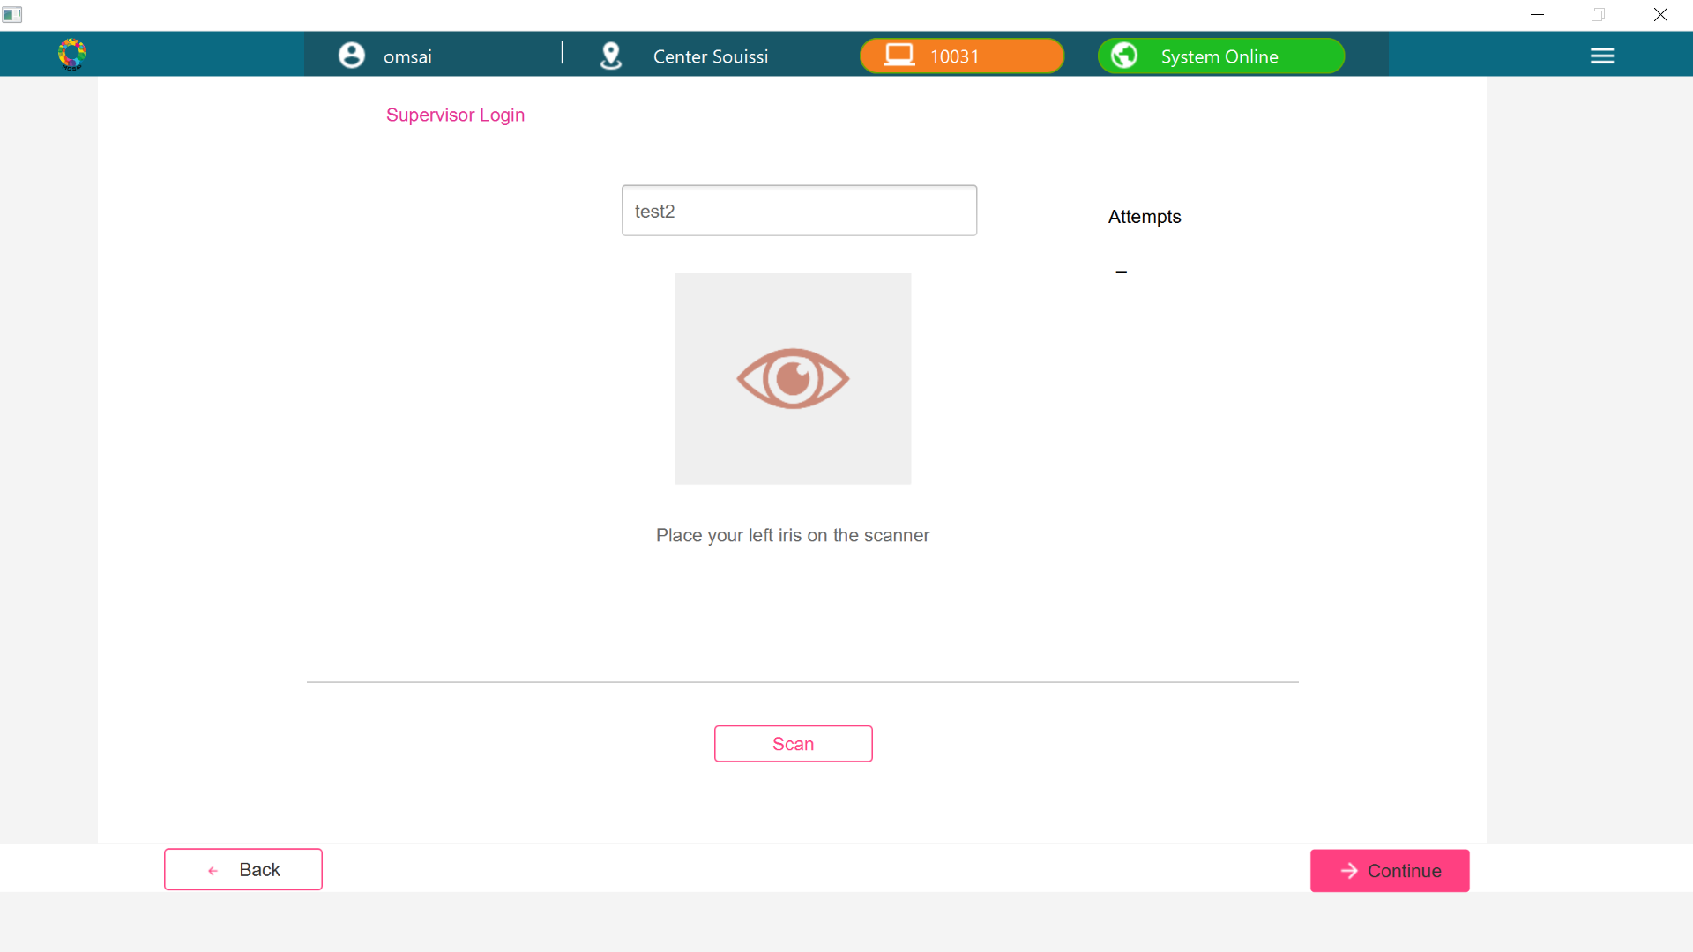

If Iris configuration is disabled, then the Supervisor Authentication screen will look as follows

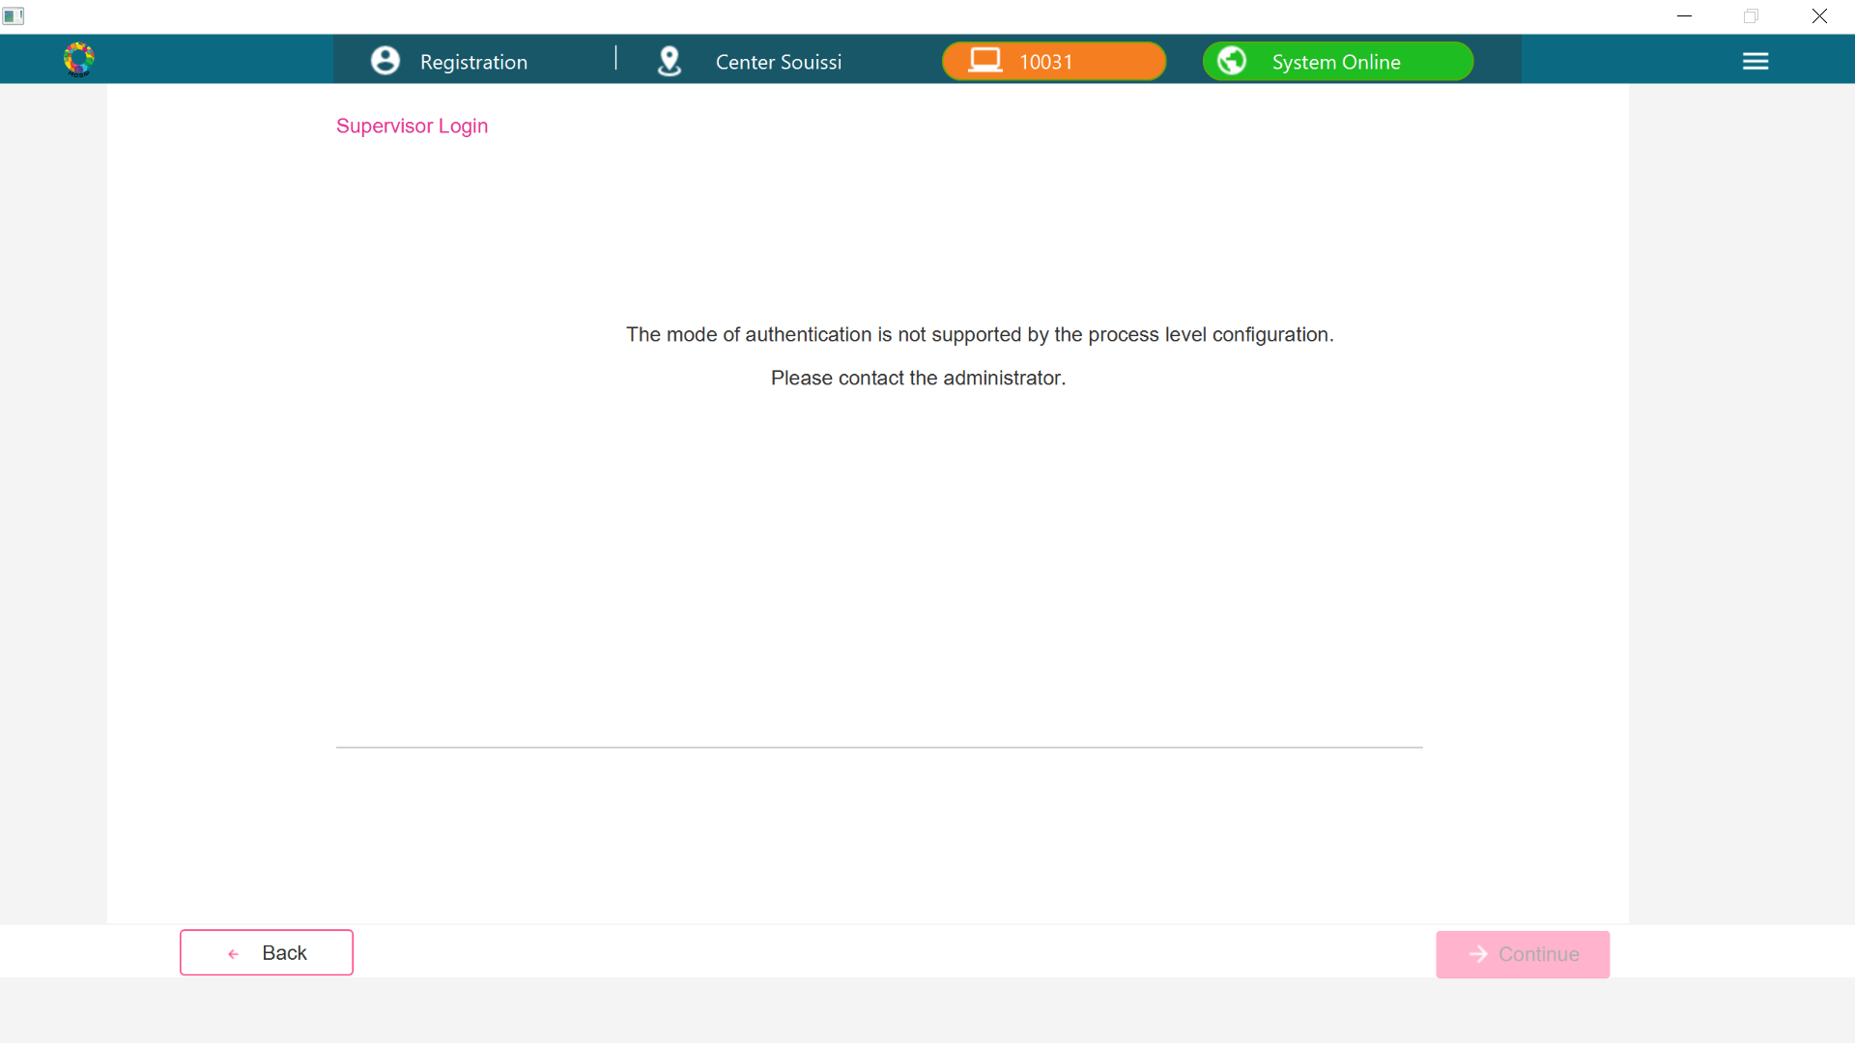

If Iris configuration is enabled, then the Acknowledgement screen will look as follows

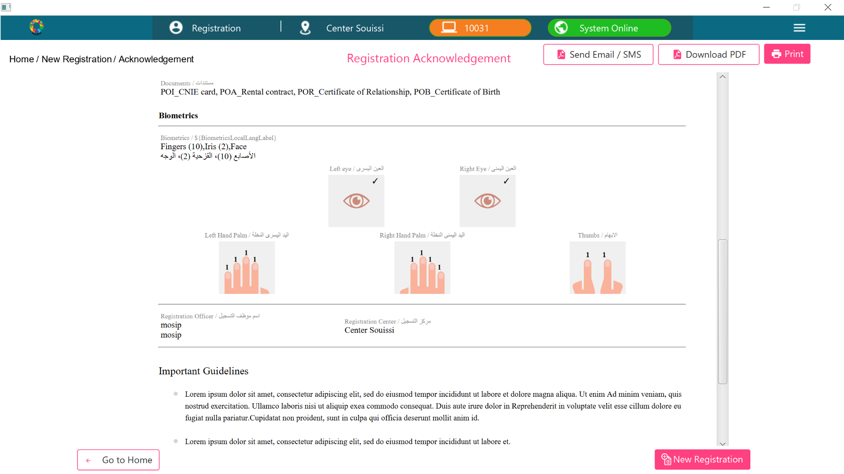

If Iris configuration is disabled, then the Acknowledgement screen will look as follows

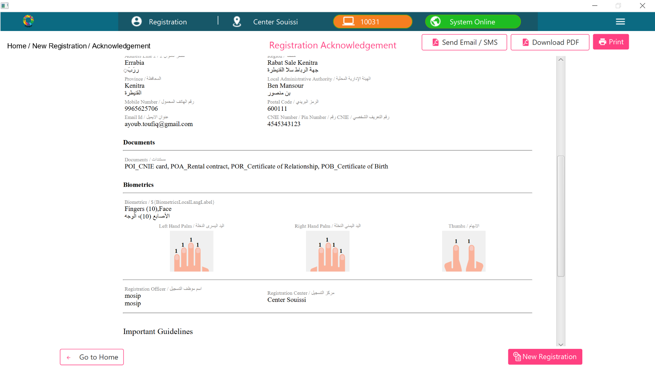

If both Iris and Fingerprint are configured to true then the biometric exception toggle will display

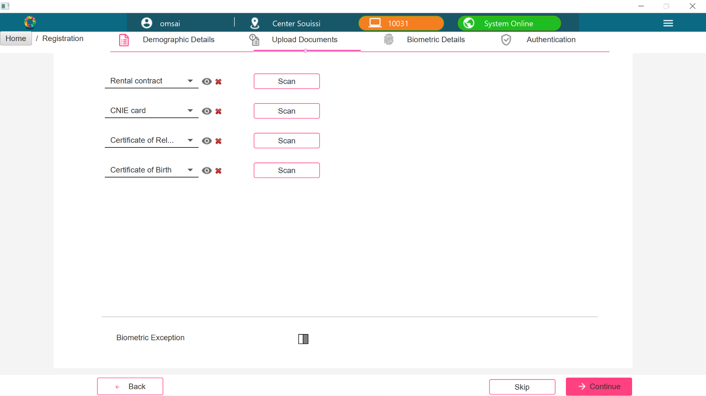

If both Iris and Fingerprint are configured to false then the biometric exception toggle will not display

